**Sugar CRM add-on to send SMS**

1. **Admin Area for configuration**
   1. We shall provide configuration panel like login, Proxy Setting where you can add credential of SMS Gateway like URL, Username and Password.

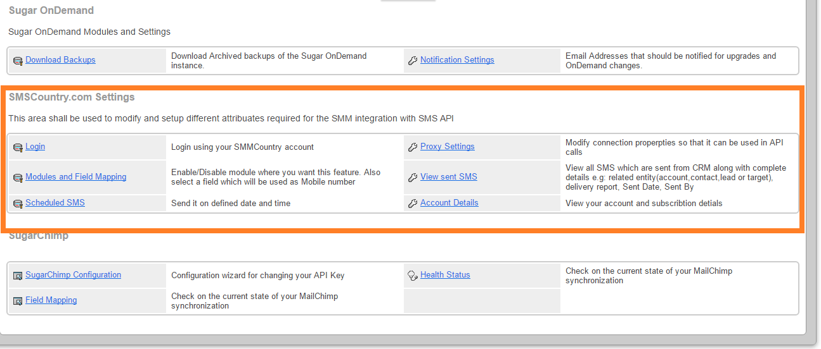

1. **Send SMS**
   1. New Module for send SMS shall be provided, where you can add number from different module like Contact, Account and Contact etc, where you can add manual entry of number and SMS. As shown in below screen shot:

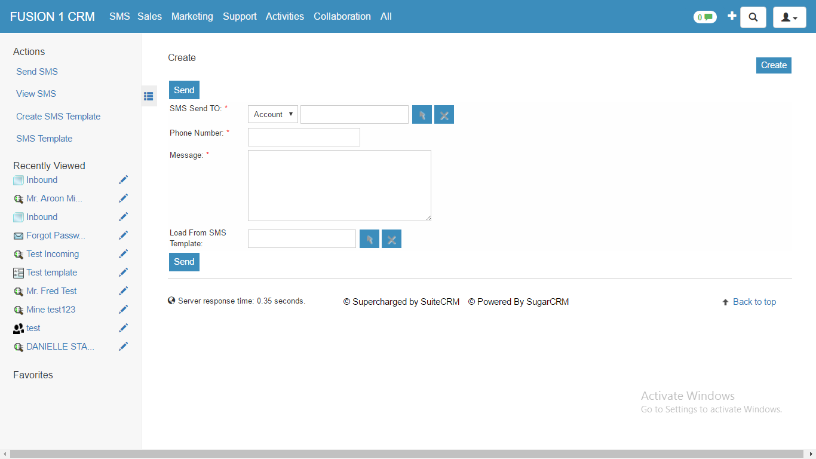

1. **Delivery status of send SMS:**
   1. we shall provide the panel from where you can also see the list of send SMS in detail view of particular SMS or in list view of SMS as mention below in screen shot:

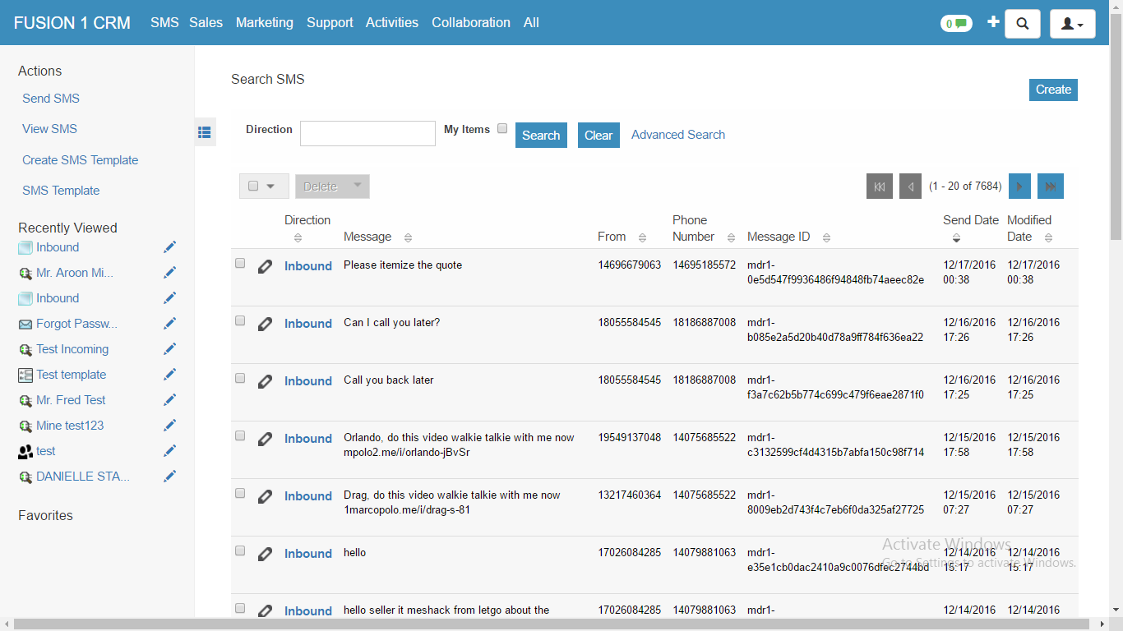

1. **SMS templates**
   1. We shall provide SMS template as shown below, where you can save template for SMS and merge different Module like Account, Contact and Leads:

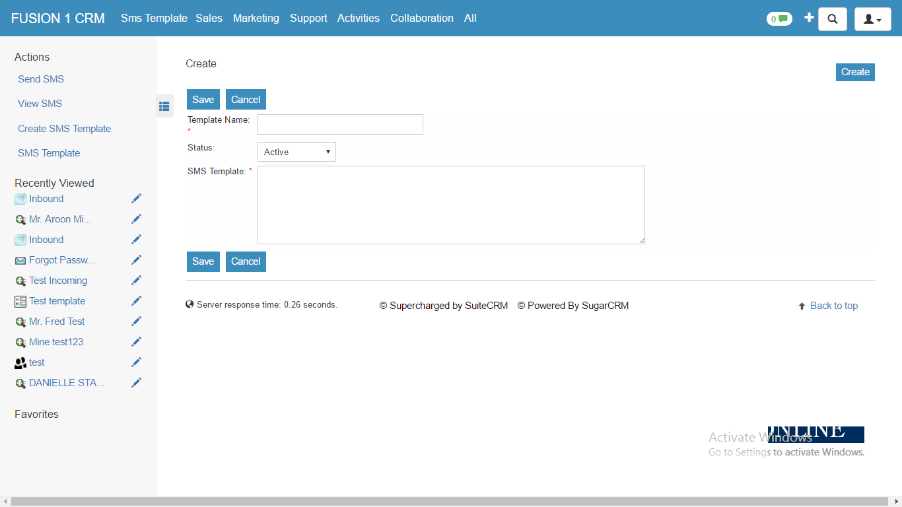

1. **List Of Template:**
   1. You can also see the list of SMS Template in detail view of particular SMS Template or in list view of SMS Template as mention below in screen shot:

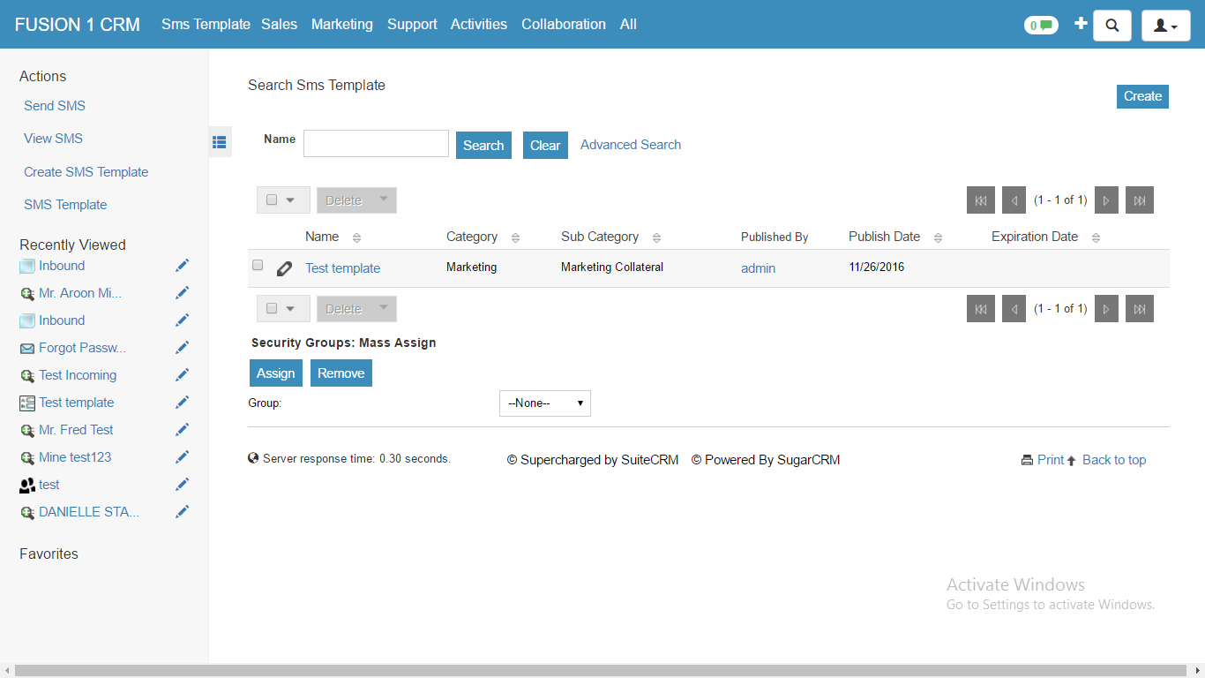

1. **Schedule SMS:**
   1. We shall provide you option to schedule SMS using default workflow where you can able to schedule or send SMS for that particular event which is set by customer, As shown in mention below both screen shot:

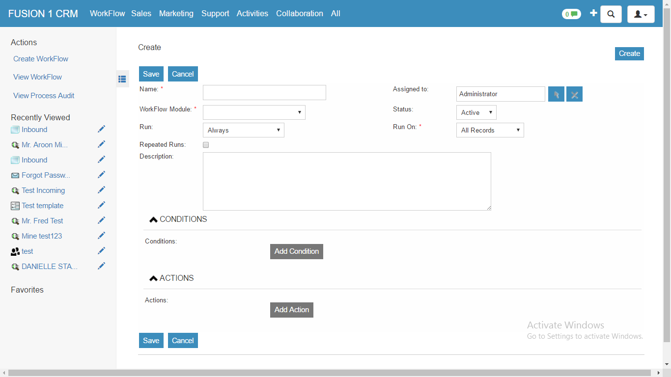

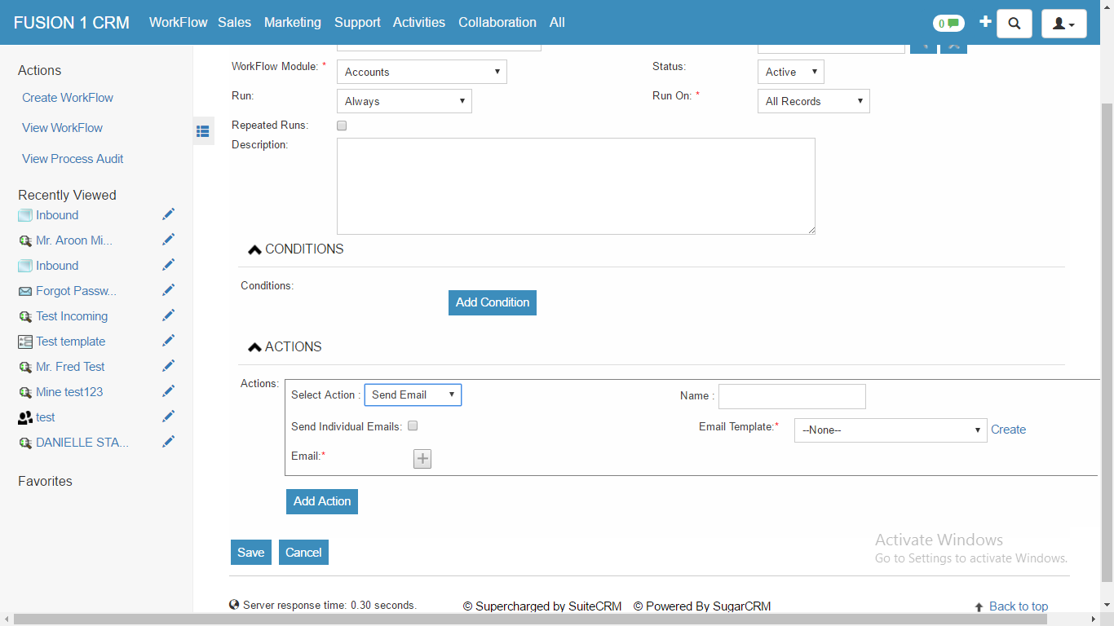

1. **Send bulk SMS**
   1. The user shall be able to send bulk SMS via List view of Accounts, Leads, Contacts and Target modules by selecting the records from List view and clicking on a new menu link available in the action menu.
2. **Requirement:**
   1. The client shall provide us the Account (login credentials) to access the APIs and SMS service.